Media Rain Garden Plant List
This is a list of the plants originally planted in the rain gardens. Not all are still there.

Partly Shade Garden
(west side of stone cottage)

1. Christmas Fern- Polystichum acrostichoides
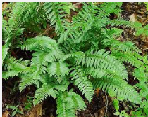

2. Golden Ragwort – Senecio aureus
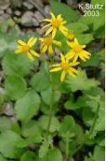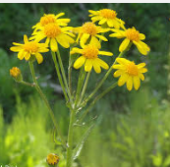

3. Barbara’s Buttons — Marshallia grandiflora
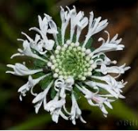
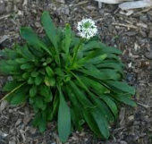

4. Blue Lobelia – Lobelia siphilitica
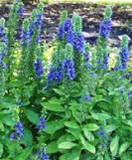

5. Blue Wood Aster – Aster cordifolius
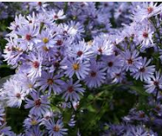

6. Labrador Violet – Viola labradorica
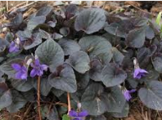

7. Blue Wood Sedge – Carex flaccosperma
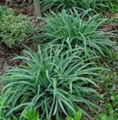

8. Pink Turtlehead – Chelone lyonii
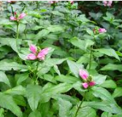

9. Crested Iris – Iris cristata
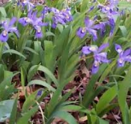

10. Sweet Pepper Bush – Clethra alnifolia
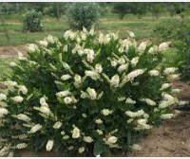
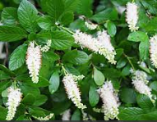

11. Red Chokecherry – Aronia arbutifolia
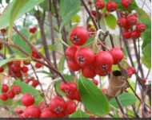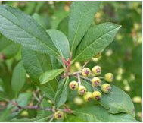

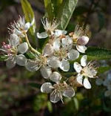

12. New England Astor – Aster novae-angliae
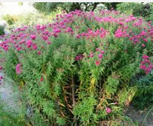

13. Swamp Mallow – Hibiscus moschuetos
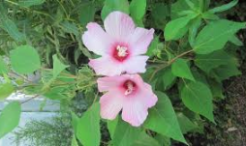

14. 'Husker Red' White Beardtongue – Hibiscus moschuetos
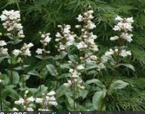
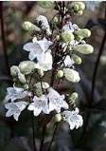

Partly Sunny Rain Garden:
(west side of stone cottage)

1. Cranberry Viburnum – Viburnum trilobum
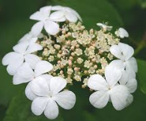
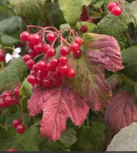

2. Blue Flag Iris – Iris versicolor
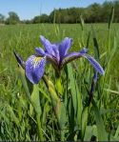

3. Tussock Sedge – Carex stricta
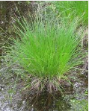

4. Cardinal Flower – Lobelia cardinalis
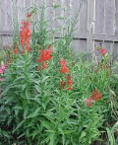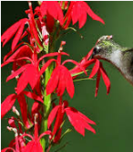

5. New England Aster – Aster novae-angliae

6. Swamp Milkweed – Asclepias incarnata
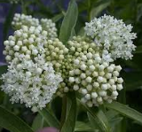
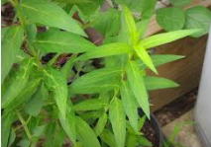
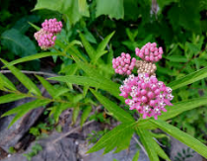

7. False Sunflower – Heliopsis helianthoides

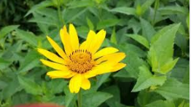

8. Willow Bluestar — Amsonia hubrichtii
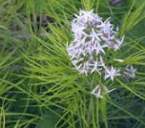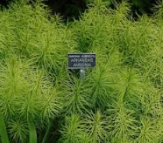

9. Virginia Meadow Beauty – Rhexia virginica
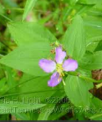

10. Bee Balm – Monarda didyma
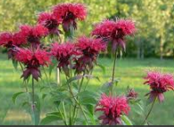

11. Blue-stemmed Goldenrod – Solidago caesia
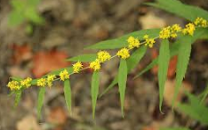

12. Red Chokecherry – Aronia arbutifolia

13. Swamp Mallow — Hibiscus moschuetos

14. Obedient Plant — Physostegia
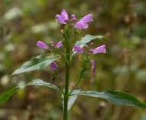

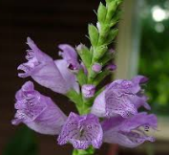

15. New York Ironweed — Vernonia novaboracensis
